22 + Kia Sportage
HD22-SP-M14588
Installation Instruction

Thank you very much for choosing our products.
Please read the installation instruction carefully before using our product and be sure to fully understand the contents mentioned above for subsequent installation.
In addition, please keep properly the installation instruction for product maintenance in future.

Attentions

- The following symbols are used in this installation instruction.
- Non-compliance may cause the problems with vehicle. Please do not install that is not recorded in this instruction.
- Please forgive that we are not responsible for any consequences arising from the installation not according to our installation instruction.

- Product Composition *Please confirm if it is missing.
1.Mounting Bracket 1 L/R  (2 pieces )  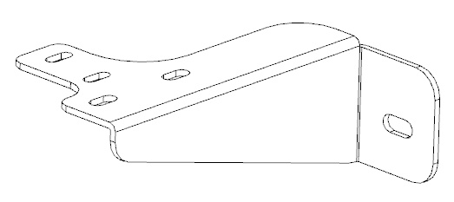 | 2.M10 U type screw  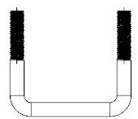  (2 pieces) | 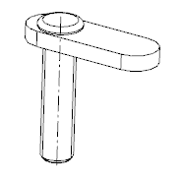  - M8 T type screw(4 pieces) | 4. M10 Flat washer    (4 pieces) | 5.M10 Lock Washer (4 pieces)  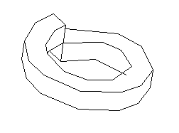
6. M10 Hex Nut (4 pieces)   | 7. M8 Flat washer  (4 pieces) | 8.M8 Lock Washer (4 pieces) | 9. M8 Hex Nut (4 pieces) | 10.M12*30 Bolt  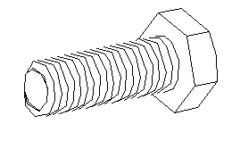  (2 pieces)
11.M12 Flat washer (2 pieces) | 12.M12 Lock Washer (2 pieces)
Ratchet  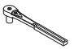 | Torque wrench  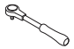 | socket  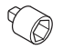 | plum wrench  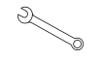

- Installation tools *Please prepare these tools before installation.

Fitting Procedure
Installation Instruction

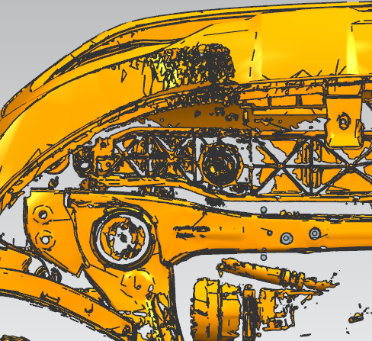

2

3

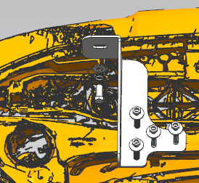
3、7、8、9
1

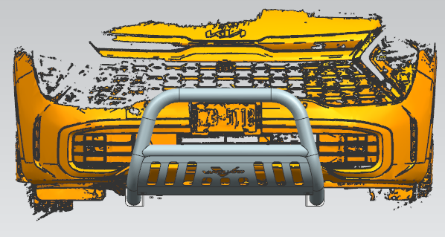

10、11、12

2、4、5、6

TIPS:
= Routine Maintenance =
Do not attach the bar to the vehicle using anchorages not intended for this purpose.
Do not use the bar for any vehicle other than those specified by the bar manufacturer.
The use of an alloy polish such as ‘Auto Sol’ is recommended for extra shine, however hot soapy water will
also clean well.
Please use neutral detergent to wet the soft cloth or suede and so on, then clean our product.

