HD19-RAM-A12340

M6*20 Bolt *2
M6 Flat Washer *2
M6 Nut *2
Lamp comes with

M6*15 Bolt *2

Lamp comes with

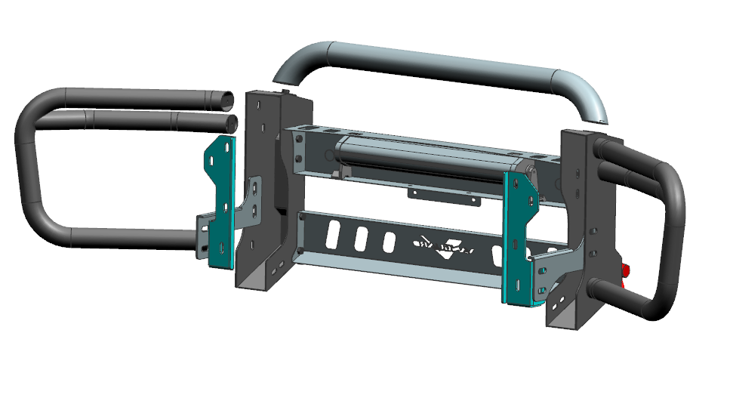
M10*25 Bolt *8
M10 Flat Washer *8
M10 Lock Washer *8
M8*25 Bolt *8
M8 Flat Washer *8
M8 Lock Washer *8
The hole is used to adjust the height

M12*35 Bolt *10
M12 Flat Washer *20
M12 Lock Washer *10
M12 Nut *10
M8*15 Bolt *4
M8 The flange nut*4

